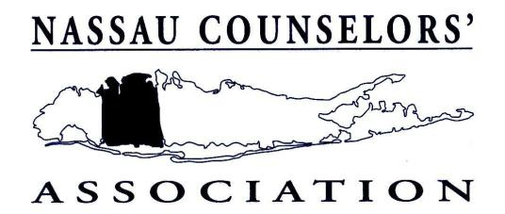

___________________________ _________________________________
December 2011
Dear Colleague:
Nassau Counselors’ Association will present this year the second annual “Stu Agins Memorial Service awards.”
Those of you who knew Stu were witness to his many contributions to the field of counseling and his dedication to
serving the counseling community. A veteran counselor and guidance administrator for many, many years, Stu
was devoted to working with, for and in support of school counselors. The work counselors do with young people
was something that Stu held very close to his heart. He immersed himself as a very active participant in every
facet of the Nassau Counselors’ Association and it was only natural that Stu served as our president in 1983-1984;
a role he approached with sincere integrity and great pride for all of the members of our organization.

This award is designed to recognize an individual who has been very much involved in service to the Nassau
Counselors’ Association and to the counseling community. In order to be considered for this award, a candidate must be nominated and must meet the criteria listed below.
• Outstanding personal and professional Qualities
• Wide and active participation in a broad array of counseling activities
• Demonstration of unique contributions to the support, advancement and advocacy of the counseling
profession and community
• Long-standing and current membership in the Nassau Counselors’ association
• A history of active Nassau Counselors’ Association committee membership
• A history of leadership within the Nassau Counselors’ Association

Two recommendation letters are required for consideration of a nominee:
• A recommendation letter from the nominating individual (who must be a current NCA member)
AND
• An additional recommendation letter from a colleague who supports the nomination and has first-hand experience and knowledge of the nominee’s contributions as outlined above.
Kindly submit both nomination forms in a single packet by March 23, 2012. The Stu Agins Memorial Service Award recipient will be announced and recognized at the June 2012 Nassau Counselors’ Association Awards Meeting.
Sincerely,

Robert A. Germino, Chairperson
Stu Agins Memorial Service Award

