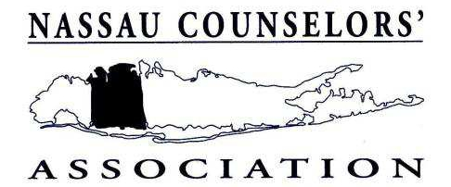

Now Accepting Applications for the
2011 - 2012
EXEMPLARY GUIDANCE PRACTICE AWARD

The Nassau Counselors’ Association will recognize a noteworthy accomplishment of a counseling staff in Nassau County Schools by presenting an award for outstanding guidance practice. We are very much interested in any and all new ideas you may be implementing in your school, and will award a prize to the one judged to be the best in June 2012. The Exemplary Guidance Practice Committee has established the following guidelines in its
consideration of nominees’ programs or activities:

1. Innovative
2. Specific
3. Currently in practice
4. Easily adaptable to other schools
Committee members will visit schools whose entries have met the above-mentioned guidelines. Visits will take place in early spring. Applications will be accepted until March 23, 2012.
The counselor(s) from the winning school will be asked to present their program at LICAC. The Award will be presented at NCA’s End of the Year Gathering.

In order to nominate your school for the 2011-2012 Exemplary Guidance Practice Award, fill in the information
below and return this form along with a detailed written description of the guidance practice and all related
materials to the address at the bottom. Please submit 5 copies of all materials including directions to your
school.
Name of School: _____________________________________________________________________
Address: ____________________________________________________________________________
Phone: ____________________________________________________________________________

Counselor Submitting Nomination (NCA Members Only)
Name: _____________________________________________________________________________ Title: _____________________________________________________________________________
Return Nomination Forms to:
Tara Bilicki
Nassau BOCES, Barry Tech Career and Technical Education Center
1196 Prospect Ave.
Westbury, NY 11590
Phone: 516-622-6952

DEADLINE FOR SUBMISSION - MARCH 23, 2012

