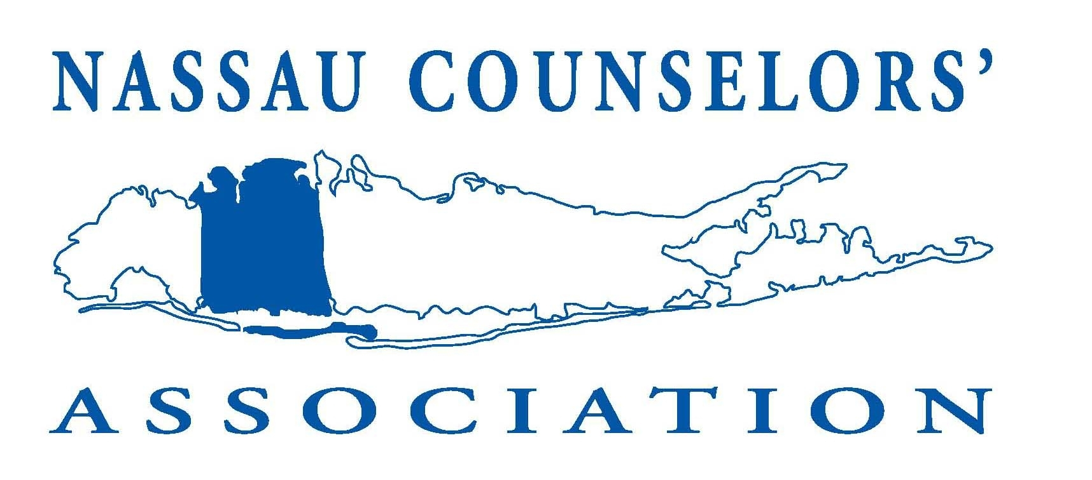
NASSAU COUNSELORS' ASSOCIATION
2018/19 MEMBERSHIP APPLICATION

Membership Year:
July 1st through June 30th

Annual directory listing guaranteed to those who join by September 30th

(Please Print or Type)
NAME: CURRENT POSITION:

INSTITUTION:

WORK SETTING: □ ELEM. SCH. □ MIDDLE/JUNIOR HIGH SCH. □ SENIOR H.S.
□ COLLEGE □ PROPRIETARY SCHOOL □ AGENCY/OTHER
□ GRADUATE STUDENT
BUSINESS ADDRESS:
CITY STATE ZIP+4
BUS. PHONE: E-MAIL
HOME ADDRESS:
CITY STATE ZIP+4
HOME PHONE: E-MAIL

PLEASE SEND MAIL TO MY: □ HOME ADDRESS □ BUSINESS ADDRESS

MEMBERSHIP CLASSIFICATION: (See descriptions below)

□ REGULAR ($30.00) □ ASSOCIATE ($30.00) □ LIFE (No Fee) Year granted ______
□ RETIRED ($20.00) IF RETIRED, PREVIOUS POSITION/INSTITUTION ______
□ STUDENT ($20.00) IF STUDENT, PLEASE HAVE AN INSTRUCTOR COMPLETE NEXT SECTION

I hereby certify that this applicant is a matriculated student at ____________________________________
Signature of Instructor _________________________________________________________________

ANNUAL MEMBERSHIP DUES AND MEMBERSHIP CLASSIFICATIONS

REGULAR $30.00 Any person whose professional work responsibilities are in the area of counseling and/or human development
services and either resides or is employed in Nassau County of New York State is eligible to become a Regular Member.

ASSOCIATE $30.00 Any person who does not qualify for Regular Membership, but who is professionally associated in the field of counseling is eligible to become an Associate Member.

RETIRED $20.00 Any person who was a regular member and who retired from a position in the field of counseling and/or human
development services is eligible to become a Retired Member.

STUDENT $20.00 Any person not eligible for Regular membership and who is a graduate student preparing for professional work in
the field of counseling and/or human development services is eligible to become a Student Member.

LIFETIME N/A Any person who received lifetime membership, please make sure to send in your current information yearly.

PLEASE MAIL THIS COMPLETED APPLICATION,
ALONG WITH YOUR CHECK PAYABLE TO NASSAU COUNSELORS’ ASSOCIATION, INC.
TO:

PLEASE MAIL THIS COMPLETED APPLICATION, ALONG WITH YOUR CHECK,

PAYABLE TO NASSAU COUNSELORS’ ASSOCIATION, INC.
TO:
NASSAU COUNSELORS’ ASSOCIATION
EXECUTIVE OFFICE
708 PEASE LANE
WEST ISLIP, NY 11795

