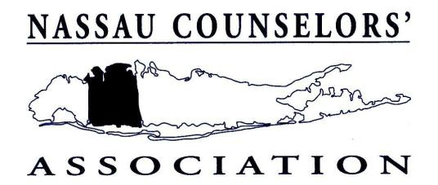

A

2012 MINI-GRANT ROGRAM

Dear Colleague,
The Nassau Counselors’ Association is once again announcing the Mini-Grant Program for the purpose of awarding grant money to worthy counseling programs. The purposes of this program are:
• To encourage the implementation or expansion of innovative counseling programs or projects.
• To promote the positive image of school counselors and admissions counselors and the field of
counseling through public relations and new ideas.
• To put available funds to use in a professional manner.

The implementation of the program will be as follows:
1. Proposals will be submitted to and reviewed by a committee.
2. A maximum of one thousand dollars ($300.00) will be allocated to a deserving program(s)
clearly showing time, training and materials needed for successful initiation, completion and
replication.
3. If no proposals are submitted which meet the committee’s criteria, no grant will be awarded.
4. Recipient(s) of the award will be expected to submit a written description of the program and
an analysis of the results to the NewsCAster by November 2012.
5. Recipients(s) will also be required to deliver a workshop presentation of the program at an NCA
meeting or an NCA sponsored event.
If you have a proposal or a project that you would like to pursue, please complete the application on the reverse side of this letter and submit for consideration by March 23, 2012. Winner(s) will be
announced and grant money awarded at the June 2012 Awards Meeting.

Sincerely,

Robert A. Germino
Mini-Grant Chairperson

Mail materials to: Mr. Robert A. Germino, 36 Cathedral Avenue #4A, Hempstead, NY 11550

A

NCA * APPLCATION FOR MINI-GRANT
Name _______________________________________________________________
Title _______________________________________________________________
ADDRESS _______________________________________________________________
EMPLOYER _______________________________________________________________

STATEMENT
Objectives: ________________________________________________________________
____________________________________________________________________________
____________________________________________________________________________
____________________________________________________________________________
____________________________________________________________________________
____________________________________________________________________________
Need: ________________________________________________________________
____________________________________________________________________________
____________________________________________________________________________
____________________________________________________________________________
____________________________________________________________________________
____________________________________________________________________________
Method: ________________________________________________________________
____________________________________________________________________________
____________________________________________________________________________
____________________________________________________________________________
____________________________________________________________________________
____________________________________________________________________________
Budget: (Itemized) __________________________________________________________
____________________________________________________________________________
____________________________________________________________________________
____________________________________________________________________________
____________________________________________________________________________
____________________________________________________________________________
Attach any additional information that further describes your proposal.
Submit by March 23, 2012 to: Mr. Robert A. Germino, 36 Cathedral Avenue #4A, Hempstead, NY 11550

