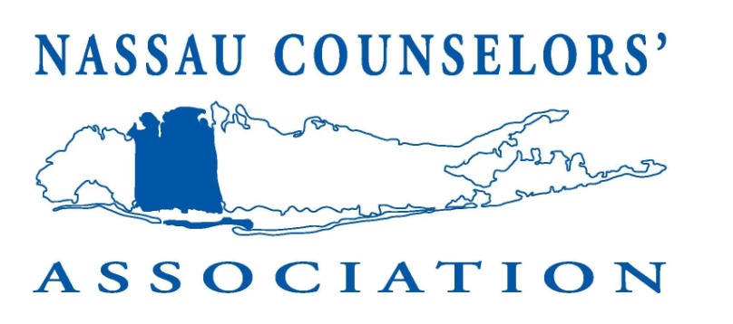

Attention all students and parents!
The NCA Fall Expo is on Sunday, September 22, 2013.
That's just around the corner!

Are you tired of filling out those address cards at each college fair? If so, then
pre-register for the Sept. 23rd, 2012 NCA Fall College Expo and throw away your pen!
Get a pre-registered barcode at www.GoToCollegeFair.com.

It's secure, fast and easy and will give you more time to speak with the College representatives!

Streamline the College Fair Experience: Pre-register for the NCA Fall Expo
Pre-register now for the September 23, 2012 NCA Fall Expo event at SUNY College at Old Westbury. Its easy and will make your college fair experience more valuable! You won't need to wait on line to fill out inquiry cards, just scan your registration bar-code and that's it (you can even use your smartphone to do it)!

It's easy and it's secure. Information is only given to the College Admission's representative.

Click here to sign up https://www.gotocollegefairs.com/Registration/EventSelectForState?StateName=New_York and select the NCA Fall College Expo in Old Westbury, New York on September 22, 2013.

Already have a barcode registration form?
Don't forget to update your contact information or your profile. Log in to your account at www.gotocollegefairs.com and update it.

Be ready to meet with over 250 Colleges on Sunday, September 22, 2013 from Noon to 3:00 PM at SUNY College at Old Westbury. For more details visit www.nassaucounselors.org.

