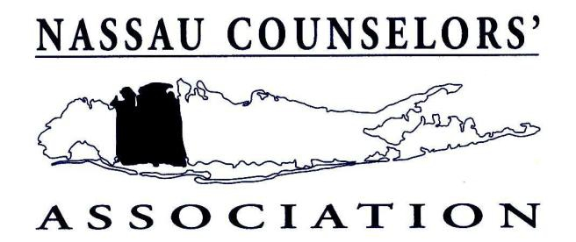

Dear Colleague,

Nassau Counselors’ Association (NCA) has long been one of the premier
professional organizations for all aspects of counseling and has consistently
acknowledged positive contributions to our field. This year, NCA is again
honored to present the annual “College Counselor of the Year” award.

This award is designed to recognize an individual from within the college
counseling setting who has consistently gone above and beyond his/her job
description to give service to the counseling profession as a whole. College
counseling includes admissions, financial aid, student services, transfer advising, leadership of a counselor education program, and a whole array of other
important administrative roles.
In order to be considered for this award, a candidate must be nominated and
must meet the criteria listed below. In addition, the nominee must have been a
member of NCA for the 2010/11 year and renewed their membership for the
current 2011/12 year. The following guide should be used as a basis for the
nomination:
• Outstanding personal and professional qualities;
• Demonstrated initiative in the advancement of the college counseling
profession both within his/her own organization and in the counseling
community at large;
• Demonstrated progressive advancement within, and contributions to, the
counseling community;
• A rich history of leadership, mentoring and professional development for
his/her team;
• Wide participation in a broad array of professional activities.
Two recommendation forms are required for consideration of a nominee:
• A completed recommendation from the nominating individual (who must
be a current NCA member) AND
• One additional recommendation from a supervisor/administrator and/or
student, client, colleague who supports the nomination.
Kindly submit all material in a single packet by March 23, 2012.
Only include the two recommendation letters, as no additional information will be considered.
Mail materials to: Dianne Guarino, Admissions
Nassau Community College
1 Education Drive
Garden City, NY 11530

Thank you for your support,
The College Counselor of the Year Committee

NASSAU COUNSELORS’ ASSOCIATION
2011/12 COLLEGE COUNSELOR OF THE YEAR

NOMINATOR’S RECOMMENDATION FORM

(Name of Nominee) (Title and Institution)

(Name of Nominator) (Title and Institution)

________________________________________________________________
(Address) (Phone Number/Email)

Please provide the committee with supporting statements about your nominee, giving your observations and judgments concerning the candidate’s qualification for the award. Please include the following in your appraisal:
• Outstanding personal and professional qualities;
• Demonstrated initiative in the advancement of the college counseling
profession both within his/her own organization and in the counseling
community at large;
• Demonstrated progressive advancement within, and contributions to, the
counseling community;
• A rich history of leadership, mentoring and professional development for
his/her team;
• Wide participation in a broad array of professional activities.

NASSAU COUNSELORS’ ASSOCIATION
2011/12 COLLEGE COUNSELOR OF THE YEAR AWARD

RECOMMENDATION FORM

(For use by: Supervisor/Administrator, and/or student, client, colleague of the nominee)

(Name of Nominee) (Title and Institution)

(Name of Supporter) (Title and Institution)

Please provide the committee with a supporting statement, giving your
observations and judgments concerning the candidate’s qualification for the award. Please include comments about the nominee’s qualities, skills and accomplishments.

RETURN THE COMPLETED FORM TO THE NOMINATOR, WHO WILL FORWARD ALL MATERIAL TO THE COMMITTEE. THANK YOU.

