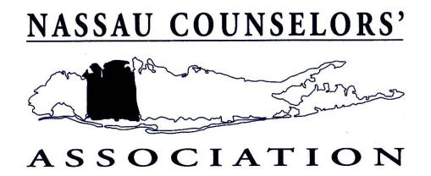

2012 ADMINISTRATOR OF THE YEAR

Dear Colleague,
The Nassau Counselors’ Association is once again planning to recognize the outstanding support rendered to the counselor practitioner by administrators in Nassau County through the Administrator of the Year Award.

Nominations of outstanding individuals can be made by any member of the Nassau Counselors’ Association. It is important to note that candidates eligible for the award cannot be directly responsible for supervising the counselor(s) or human development specialist(s) in their institution. The basis for nomination should include demonstrations of the following on the part of the nominee:

◻ Belief in the value of counselors and counseling services
◻ Evidence of that belief through reliable actions
◻ Demonstrated support of the use of counselors in a manner consistent with their defined role

The following information should be submitted for each nominee:

1. A completed recommendation form by the nominator.
2. Two additional recommendation forms completed by a counselor, supervisor, or administrator who supports
this nomination.
3. PLEASE SUBMIT ALL MATERIAL IN ONE (1) PACKET AND DO NOT SUBMIT MORE THAN
THE MATERIAL REQUESTED.
The Administrator of the Year will be recognized at our June 2012 Awards meeting. All nominees will receive a letter of congratulations on being nominated for their support of the counseling profession.

Sincerely,

Debbie Roth
Chairperson

Material must be received by March 23, 2012. Mail to:
Debbie Roth
Guidance Office
John F. Kennedy High School
3000 Bellmore Avenue
Bellmore, New York 11710

NASSAU COUNSELORS’ ASSOCIATION

2012 ADMINISTRATOR OF THE YEAR

NOMINATOR’S RECOMMENDATION FORM

_______________________ ________________________
(Nominee’s Full Name) (Position and Place of Employment)

__________________________________ ____________________________________
(Nominator’s Name - NCA Members Only) (Nominator’s Place of Employment)

Please provide the committee with supporting statements about your nominee, giving your observation and judgments concerning the candidate’s qualification for the award in each of the areas listed below:
1. Belief in the value of counselors and counseling services

-1-

2. Actions which demonstrate the nominee’s belief in the value of counselors and
counseling services

3. Examples of the nominee’s demonstrated support of the appropriate use of the counselors in his/her
institution

4. Additional comments

-2-

NASSAU COUNSELORS’ ASSOCIATION
2012 ADMINISTRATOR OF THE YEAR
RECOMMENDATION FORM

(To be used by a Counselor, Supervisor or Administrator, as appropriate)

_______________________________________ ___________________________________
(Nominee’s Name) (Place of Employment)

_______________________________________ ___________________________________
(Supporter’s Name) (Supporter’s Position)

Please provide the committee with a supporting statement, giving your
observations and judgments concerning the candidate’s qualifications for the
award. Please include comments about the nominee’s qualities and/or actions
which are indicative of his/her support for counselors and/or counseling services.

(PLEASE RETURN THE COMPLETED FORM BY 03/23/12 TO THE NOMINATOR WHO WILL FORWARD ALL MATERIAL TO THE COMMITTEE) THANK YOU!

-3-

